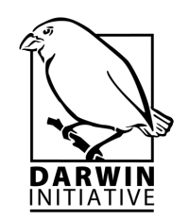
Information Day for Darwin Applicants
7 November 2013
13:00-16:30
ZSL
Zoological Society of London
Regent's Park
London NW1 4RY

Time | Agenda Item
12:30 | Arrivals and registration
13.00 | Welcome and intro to the workshop  - Purpose of the workshop  - Introductions  - How the afternoon will work
13:10 | Overview of Frequently Asked Questions (Rebecca/Eildh)  - Collection of questions that have come in and responses  - Administrative Queries  - Technical Queries  - ODA requirements
13:30 | Setting objectives: practical tips & jargon guide (Andy)  - Introduction  - Problem analysis  - Tools you can use (Theory of change, participatory planning)  - Hierarchal logic
13:40 | Measuring Impact vs. Activity (Rebecca)  - Impacts  - Outcomes  - Activities  - Indicators
13.50 | SMARTen your indicators (Paddy Abbot)  - Specific  - Measurable  - Achievable  - Realistic  - Timebound
14.00 | Group work exercise (Andy)  - Logframe puzzle  - Assessment of SMARTness of Indicators  - Theory of Change diagram drafting
14.50 | Report backs on group work
15.15 | Presenting Evidence (Rebecca)  - Means of Verification  - Using evidence to promote success
15:30 | Individual action plan and evaluation of workshop
16.15 | Q&A and Feedback
16.30 | Workshop close

