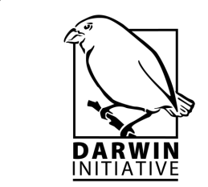
Workshop for New Darwin Projects
4th April 2014

IIED
80-86 Gray’s Inn Road
London
WC1X 8NH

Time | Agenda Item
09.30 | Arrivals and refreshments
10.00 | Welcome and intro to the workshop  - Purpose of workshop  - Day’s agenda  - Intro of all participants – name, institution, project title.
10.15 | Welcome by Darwin Secretariat  - Intro to the history of Darwin  - Into to the overall objectives of Darwin  - Intro to the various entities involved e.g. Darwin Secretariat, DEC, DFID, FCO, LTS  - Official welcome to new projects
10.25 | Introduction to the Darwin Expert Committee  - Who they are  - What they do  - Why they do what they do etc.
10.35 | Introduction to Darwin Initiative reporting systems  - Technical reporting  - Financial reporting  - Change requests
11.00 | Q&A  Refreshments & Elevator Pitch
11.30 | Elevator pitch feedback  Writing a Press Release
12.00 | Drawing on the Darwin Initiative resources to promote projects  - Website  - Newsletter  - Social media including Twitter, Facebook & LinkedIn
12.15 | Q&A
12.30 | Lunch
13.30 | SMARTen your indicators  - Ensuring the indicators you have proposed are specific, measurable, achievable, realistic and time-bound  - Output indicators vs. activity indicators vs. outcome indicators
13.40 | Developing an M&E plan  - Who measures what?  - How do they measure it?  - When do they measure it?
13.50 | Developing your communications strategy  - Identifying stakeholders – influence vs. interest  - How to communicate (not disseminate)?  - When to communicate?
14.00 | Group Exercises  - SMARTen Indicators  - Developing M&E plan  - Communications strategy
15.00 | Tea & Coffee
15.30 | Group Exercises  - SMARTen Indicators  - Developing M&E plan  - Communications strategy
16.25 | Highlights Session
16.30 | Close

